SIOP SERO Order List 2026

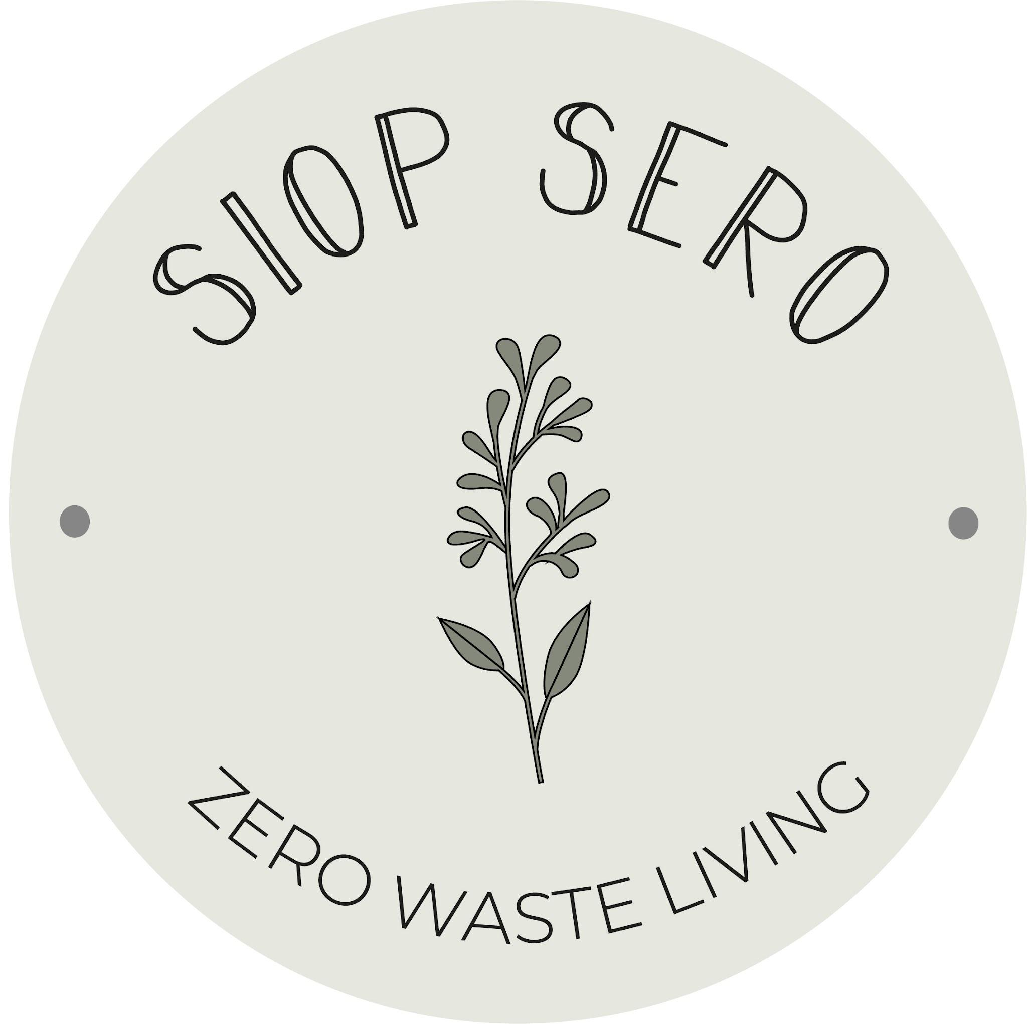

Free Order and Pick up
How to order

Click the link in bio (IG or Facebook), to find our shopping list.
Save a copy for you to add your requirements.
Email your order to hello@siopsero.co.uk

Wait for your confirmation email response from the team

Collect your order from the store during our collection hours.
Tuesdays and Fridays 2-5pm, Sundays 12-3pm

🛒
Order and In-store Pick up Guidelines

£10 minimum spend
please specify how much you’d like to spend on each item OR the closest weight (eg 100g of walnuts) -type next to item you’d like.

for allergen/ingredient information, please ask staff when you order

out of stock products will be highlighted

We use 100% recycled paper bags for dry goods, or you can drop off your own containers to the shop for us to fill.

For liquids, you have these options: you can drop off your jars, OR purchase a jar which you can return on your next collection (to be washed and reused).

Add a note in your form to let us know if you’ll be dropping off your jars/containers.

dried fruits / 100g | cereals / 100g
apricots (unsulphured) (o). . . .£1.95 | bran flakes (vg) . . . . . . . . . . . . . . . . . 37p
apricots (chopped) . . . . . . . . . .80p | bran fruit and fibre (vg) . . . . . . . . 42p
banana chips . . . . . . . . . . . . . 60p | chocolate stars (gf, vg) . . . . . . . . . 88p
coconut chips . . . . . . . . . . . . . . £1.05 | granola, coconut (vg) . . . . . . . . . . . 48p
coconut (desiccated) . . . . . . . .75p | granola, berry . . . . . . . . . . . . . . . . . 58p
crystallised ginger . . . . . . . . . . 72p | granola, deluxe . . . . . . . . . . . . . . . . .42p
cranberries . . . . . . . . . . . . . . . . 90p | muesli, base (vg) . . . . . . . . . . . . . . . 21p
currants . . . . . . . . . . . . . . . . . . . .65p | muesli, deluxe (vg) . . . . . . . . . . . . . 42p
dates (pitted) . . . . . . . . . . . . . . . 44p | oats, porridge (vg) . . . . . . . . . . . . . . 14p
dates (medjool) . . . . . . . . . . . . . £1.90 | oats, porridge (o, vg) . . . . . . . . . . . .22p
dates (chopped) . . . . . . . . . . . . 29p | oats, jumbo (o, vg) . . . . . . . . . . . . . . 22p
figs . . . . . . . . . . . . . . . . . . . . . . . . .£1.13 | oats, gluten-free (vg, gf) . . . . . . . . 44p
goji berries . . . . . . . . . . . . . . . . .£1.84
luxury mixed fruit . . . . . . . . . . . 48p
mango (o) . . . . . . . . . . . . . . . . . . £2.35 | sugars / 100g
papaya . . . . . . . . . . . . . . . . . . . . .£1 | caster sugar . . . . . . . . . . . . . . . . . . . 19p
prunes . . . . . . . . . . . . . . . . . . . . . .80p | coconut sugar (o) . . . . . . . . . . . . . . 82p
raspberries (freeze-dried) . . . £8 | granulated sugar . . . . . . . . . . . . . . 16p
strawberries (freeze-dried) . . £6 | light brown soft . . . . . . . . . . . . . . . . 26p
sultanas . . . . . . . . . . . . . . . . . . . .48p | dark brown soft . . . . . . . . . . . . . . . . 26p
sundried tomatoes . . . . . . . . .£1.20 | icing sugar . . . . . . . . . . . . . . . . . . . . .25p
vg = vegan, gf = gluten-free, o = organic

liquid cleaning products / 100g | miscellaneous cleaning / 100g
laundry liquid (neroli) . . . . . . . . . . . . . . 55p | epsom salts . . . . . . . . . . . . . . . . . . . . . . 60p
laundry liquid (unscented) . . . . . . . . . 52p | bicarbonate of soda . . . . . . . . . . . . . .36p
fabric conditioner (neroli). . . . . . . . . . . 42p | citric acid . . . . . . . . . . . . . . . . . . . . . . . . 90p
hand soap (fig) . . . . . . . . . . . . . . . . . . . . . 58p | laundry powder . . . . . . . . . . . . . . . . . . .60p
hand soap (rose) . . . . . . . . . . . . . . . . . . . .52p
washing up liquid (ginger) . . . . . . . . . 35p | 500ml glass/aluminium bottles for refill . . . . . . . £3
washing up liquid (unscented). . . . . 35p | 1000 ml aluminium bottles for refill . . . . . . .£4
cleaning vinegar . . . . . . . . . . . . . . . . . . . 20p
all purpose spray . . . . . . . . . . . . . . . . . . . 36p
toilet cleaner . . . . . . . . . . . . . . . . . . . . . . . 36p
rinse aid . . . . . . . . . . . . . . . . . . . . . . . . . . . .43p

body & hair products / 100g | soaps
AlterNative conditioner . . . . . . . . . . . . . . 62p | Faith in nature naked soap, unfragranced . . . £2.50
AlterNative conditioner . . . . . . . . . . . . . . 62p | Faith in nature naked soap, hemp and green tea . . . £2.50
AlterNative conditioner . . . . . . . . . . . . . . 62p | Faith in nature naked soap, tea tree . . . £2.50
AlterNative conditioner . . . . . . . . . . . . . . 62p | Faith in nature naked soap, lavender . . . £2.50
AlterNative conditioner . . . . . . . . . . . . . . 62p | Faith in nature naked soap, grapefruit & orange . . . £2.50
AlterNative shampoo . . . . . . . . . . . .. . . . . .62p | Faith in nature naked soap, aloe vera . . . £2.50
AlterNative shampoo . . . . . . . . . . . .. . . . . .62p | Friendly conditioner bar, eucalyptus peppermint . . . . . . . . . . .£8.99
AlterNative shampoo . . . . . . . . . . . .. . . . . .62p | Friendly shampoo bar fragrance free. . . . . . . ..£3.25
Faith in nature body wash, grapefruit orange . . . . . . . . . . . 95p | Friendly shampoo bar,lavender geranium. . . . . . . ..£3.25
Faith in nature body wash, lavender geranium . . . . . . . . . . . 95p | Friendly shampoo bar, . . . . . . . ..£3.25
Faith in nature body wash, wild rose . . . . . . . . . . . 95p | Friendly shaving bar, orange lavender . . . . . . . . . £3.25
 | 500ml glass/aluminium bottles for refill . . . . . . . £3

baking / 100g | rices / 100g
baking chocolate drops (vg) . . . . . . . .£3.45 | arborio . . . . . . . . . . . . . . . . . . . .45p
belgian chocolate drops . . . . . . . . . . . £2 | basmati brown . . . . . . . . . . . . 41p
baking powder . . . . . . . . . . . . . . . . . . . . . 65p | basmati white . . . . . . . . . . . . . 30p
bicarbonate of soda . . . . . . . . . . . . . . . . 36p | brown long grain . . . . . . . . . . 28p
cacao nibs (o)(vg) . . . . . . . . . . . . . . . . . . £3.95 | mixed wild rice (o) . . . . . . . . . .80p
cacao powder (vg)(o). . . . . . . . . . . . . . . £2.80
cocoa powder (vg) . . . . . . . . . . . . . . . . . £1.35
cornflour (vg). . . . . . . . . . . . . . . . . . . . . . 35p | seeds / 100g
plain flour (gf). . . . . . . . . . . . . . . . . . . . . 34p
plain white flour (o) . . . . . . . . . . . . . . . .22p | golden linseed (flax) (o). . . . .55p
self-raising flour (o) . . . . . . . . . . . . . . . . 24p | chia seeds (o) . . . . . . . . . . . . . .£1.15
strong white bread flour (o) . . . . . . . 20p | hulled hemp seed (o) . . . . . . £1.65
wholemeal bread flour (o). . . . . . . . . .22p | omega 4 seed mix . . . . . . . . . 50p
 | poppy seeds (o) . . . . . . . . . . . .£1.90
 | pumpkin seeds (o). . . . . . . . . .75p
 | sesame seeds . . . . . . . . . . . . . 70p
 | sunflower seeds . . . . . . . . . . . .40p
vg = vegan, gf = gluten-free, o = organic

grains / 100g | beans, pulses & legumes / 100g
bulgar wheat . . . . . . . . . . . . . . . 32p | black turtle beans . . . . . . . . . .36p
cous cous . . . . . . . . . . . . . . . . . . 29p | chickpeas . . . . . . . . . . . . . . . . . 27p
white fusilli . . . . . . . . . . . . . . . . . 30p | lentils (green) . . . . . . . . . . . . . . 31p
wholemeal fusilli (o) . . . . . . . . . 48p | lentils (puy/black) . . . . . . . . . . 42p
white penne . . . . . . . . . . . . . . . . 30p | red kidney beans . . . . . . . . . . .37p
wholemeal penne . . . . . . . . . . . 45p | yellow split peas . . . . . . . . . . . 19p
wholemeal penne (o) . . . . . . . . 48p
gluten-free penne (gf) . . . . . . . 68p
white spaghetti (o) . . . . . . . . . . 48p
wholemeal spaghetti (o). . . . . 48p | nuts / 100g
noodles (vg). . . . . . . . . . . . . . . . . 55p | almonds (ground) . . . . . . . . . . . . . .£1.20
orzo . . . . . . . . . . . . . . . . . . . . . . . . . .28p | almonds (whole) . . . . . . . . . . . . . . . £1.08
popping corn . . . . . . . . . . . . . . . .24p | almonds (flaked) . . . . . . . . . . . . . . . £1.28
pearl barley . . . . . . . . . . . . . . . . . .20p | brazil nut pieces . . . . . . . . . . . . . . . .£2.20
white quinoa . . . . . . . . . . . . . . . . 57p | cashew pieces . . . . . . . . . . . . . . . . . .£1.34
 | coconut (desiccated) (o) . . . . . . . . .67p
 | coconut (flaked) (o) . . . . . . . . . . . . . .73p
 | hazelnuts (o) . . . . . . . . . . . . . . . . . . .£1.67
 | peanuts (skin on) . . . . . . . . . . . . . . . 56p
 | peanuts (roasted salted) . . . . . . . . 58p
 | pecan halves . . . . . . . . . . . . . . . . . . .£2.13
 | pine nuts (o) . . . . . . . . . . . . . . . . . . . .£4.00
 | pistachios (roasted & salted) . . . £2.40
vg = vegan, gf = gluten-free, o = organic | walnut pieces . . . . . . . . . . . . . . . . . . £1.38

snacks / confectionary /100g
banana chips . . . . . . . . . . . . . . . . . . . . . . . . . . . . 60p | pick’n’mix, fizzy (vg) . . . . . . . . . . . . . . . . . . .£1
chocolate brazils (milk) . . . . . . . . . . . . . . . . . . .£2.15 | pick’n’mix, gummy (vg). . . . . . . . . . . . . . . £1
chocolate brazils (dark) . . . . . . . . . . . . . . . . . . .£2.15 | pretzels, salted (vg) . . . . . . . . . . . . . . . . . . 82p
chocolate coffee beans (dark). . . . . . . . . . . . .£1.75
chocolate ginger (dark) . . . . . . . . . . . . . . . . . . .£1.75
chocolate honeycomb (milk) . . . . . . . . . . . . .£1.75
chocolate honeycomb (dark). . . . . . . . . . . . . £1.75
chocolate raisins (milk). . . . . . . . . . . . . . . . . . . £1.75
chocolate peanuts (milk) . . . . . . . . . . . . . . . . .£1.75
chocolate mini eggs . . . . . . . . . . . . . . . . . . . . . £2
raw chocolate cashews (o, vg) . . . . . . . . . . . £3.60
raw chocolate almond truffle buttons(o,vg) £3.25
crisps (potato, salted) (vg, gf). . . . . . . . . . . . . .£1.67
crisps (beetroot crunch) (vg) . . . . . . . . . . £1.9/25g
fruit and nut mix (vg, gf). . . . . . . . . . . . . . . . . . 65p
fudge, strawberries and cream (vg). . . . . . . .£1.10
fudge, salted caramel (vg). . . . . . . . . . . . . . . . . £1.10
fudge, vanilla (vg). . . . . . . . . . . . . . . . . . . . . . . . . .£1.10
 | vg = vegan, gf = gluten-free, o = organic

herbs & spices / 100g
allspice . . . . . . . . . . . . . . . . . . . . . . .£1.35 | garlic powder. . . . . . . . . . . . . . . £1.20
basil. . . . . . . . . . . . . . . . . . . . . . . . . . £1.60 | ginger (ground) . . . . . . . . . . . . £1.40
bay leaves . . . . . . . . . . . . . . . . . . . .£2.00 | mint . . . . . . . . . . . . . . . . . . . . . . . . 70p
black peppercorns . . . . . . . . . . . £1.75 | mixed spice . . . . . . . . . . . . . . . . .£1.20
cayenne pepper . . . . . . . . . . . . . . .£1.30 | mixed herbs . . . . . . . . . . . . . . . . £1.44
chilli flakes . . . . . . . . . . . . . . . . . . . . £1.77 | nutmeg (whole) . . . . . . . . . . . . £3.45
chilli powder . . . . . . . . . . . . . . . . . . £1 | onion powder . . . . . . . . . . . . . . .£1.05
chinese five spice . . . . . . . . . . . . . . £1.50 | oregano . . . . . . . . . . . . . . . . . . . . £1.56
cinnamon (ground) . . . . . . . . . . . .£2.28 | parsley . . . . . . . . . . . . . . . . . . . . . .£1.65
cinnamon (quills) . . . . . . . . . . . . . .£4.95 | paprika (smoked) . . . . . . . . . . . £1.40
cloves (whole) . . . . . . . . . . . . . . . . . £2.50 | paprika (sweet) . . . . . . . . . . . . . £1.40
coriander (ground) . . . . . . . . . . . . .90p | piri piri mix . . . . . . . . . . . . . . . . . £1.73
coriander (seeds) . . . . . . . . . . . . . . 70p | poppy seeds (o) . . . . . . . . . . . . . £1.90
cumin (ground) . . . . . . . . . . . . . . . .£1.80 | rosemary . . . . . . . . . . . . . . . . . . . £1.40
cumin (seeds) . . . . . . . . . . . . . . . . . £1.70 | sage . . . . . . . . . . . . . . . . . . . . . . . . £1.35
curry powder . . . . . . . . . . . . . . . . . . 95p | salt (fine & coarse) . . . . . . . . . . 26p
fajita mix . . . . . . . . . . . . . . . . . . . . . .£1.86 | star anise . . . . . . . . . . . . . . . . . . . £4.30
fennel seeds . . . . . . . . . . . . . . . £1.50 | tandoori masala . . . . . . . . . . . £1
garam masala . . . . . . . . . . . . . £1.20 | thyme . . . . . . . . . . . . . . . . . . . . . . .£1.21
 | turmeric . . . . . . . . . . . . . . . . . . . . 80p

teas / 100g | coffee / 100g
assam . . . . . . . . . . . . . . . . . . . . . . . . . £3.75 | manumit beans . . . . . . . . . . . . £3
breakfast . . . . . . . . . . . . . . . . . . . . . . £3.28 | manumit ground (ground on order). . . . .£3
berry and kiwi. . . . . . . . . . . . . . . . . . £4.28 | manumit beans (decaf). . . . . .£3.50
ceylon . . . . . . . . . . . . . . . . . . . . . . . . . £3.75 | manumit ground (decaf) . . . .£3.50
chamomile . . . . . . . . . . . . . . . . . . . . .£4.25
chamomile & elderflower . . . . . . £4.92
darjeeling . . . . . . . . . . . . . . . . . . . . . £4.92 | oil, vinegar, sauces / 100g
earl grey. . . . . . . . . . . . . . . . . . . . . . . .£3.28 | apple cider vinegar . . . . . . . . . . . 40p
(sencha) green . . . . . . . . . . . . . . . . £3.76 | balsamic vinegar . . . . . . . . . . . . . .85p
lemongrass & ginger . . . . . . . . . . £3.28 | olive oil, extra virgin . . . . . . . . . . . £1.66
masala chai. . . . . . . . . . . . . . . . . . . . £3.90 | rapeseed oil, Welsh . . . . . . . . . . . .78p
nettle and rose . . . . . . . . . . . . . . . . £4.28 | sunflower oil . . . . . . . . . . . . . . . . . . 88p
rooibos . . . . . . . . . . . . . . . . . . . . . . . . £3.40 | soy sauce . . . . . . . . . . . . . . . . . . . . . . 49p
turmeric & ginger . . . . . . . . . . . . . £4.08 | tamari . . . . . . . . . . . . . . . . . . . . . . . . . .65p
 | Drinking chocolate / Each
 | Harth original . . . . . . . . . . £8.95
 | Harth cinnamon . . . . . . . . . . £8..95
 | Harth rose cardamom . . . . . . . . . . £10.95
 | Harth solstice spiced . . . . . . . . . . £8..95

refrigerated drinks / each
blighty booch, cherry.. . . . . . . . . . . . . . . £3.69 | Mother hen eggs . . . . . .35p each or 6 for £2
blighty booch, ginger.. . . . . . . . . . . . . . . £3.69
blighty booch, nettle rose.. . . . . . . . . . . . £3.69
blighty booch, original.. . . . . . . . . . . . . . . £3.69
equinox kombucha sicilian orange yuzu, 275ml . . . . . . . . . . . . . . . . . . . £2.70
equinox kombucha turmeric lemon 275ml . . . . . . . . . . . . . . . . . . . £2.70
Crafty picklecrafty kimchi. . . . . . . . . . . . . . . £7.69
Crafty pickle crafty kraut . . . . . . . . . . . . . . £7.69
Agua de madre kefir water, lemon ginger . . . . . . . . . . . £2.90
Agua de madre kefir water, passionfruit raspberry . . . . . . . . . . £2.90
karma cans, cherry,. . . . . . . . . . . . .£1.60
karma cans, gingerella,. . . . . . . . . . . . .£1.60
karma cans, lemonade. . . . . . . . . . . . .£1.60
karma cans, orange . . . . . . . . . . . .£1.60
karma cans, raspberry . . . . . . . . . . . .£1.60
Bonhomie lemon lime . . . . . . . . . . . . . . . . £2.50

tins & jars / each | sauces & bottles / each
carley’s cashew butter . . . . . . . . . . . . . . £4.79 | halen mon bloody mary ketchup . . . £5.50
carley’s almond butter . . . . . . . . . . . . . . £4.79
dark chocolate spread . . . . . . . .£5.99 | nature’s little helpers honey large. . . . . . . . .£7.50
essential chopped (o). . . . . . . . . . . . . . . . £1.55 | blodyn aur, welsh mayonnaise . . . £4.50
suma, butter beans (o).. . . . . . . . . . . . . .. £1.45 | welsh lady, lemon curd . . . . . . £4.40
suma, black beans (o).. . . . . . . . . . . . . .. £1.45 | welsh lady, lime curd . . . . . . £4.40
suma, aduki beans (o) . . . . .. . . . . . . . . . . £1.45 | welsh lady, wholegrain mustard . . . .£3.40
suma, chickpeas (o). . . . . . . . . . . . . . . . . . . .. £1.45 | welsh lady, tomato ketchup . . . . . . £3.90
suma, kidney beans (o). . . . . . . . . . . . . . . . . .£1.45 | welsh lady, brown sauce . . . . . . £4.30
crwst sea salted caramel . . . . . . . . . . . . . . £7
crwst welsh honey butter . . . . . . . . . . . . . . £8
crwst hazelnut caramel . . . . . . . . . . . . . . £7.35

kitchen items | personal care
dish brush silicone . . . . . . . . . . . . . . . . . . . . . £3.95 | georganics adult toothbrush medium .. . . £3.65
dish brush wooden . . . . . . . . . . . . . . . . . . . . . £5.95 | georganics toothpaste mineral jar . . . . £6.90
replacement head . . . . . . . . . . . . . . £2.50 | georganics kids bamboo toothbrush . . . ..£3.65
Bamboo towels . . . . . . . . . . . . . . £7.69 | georganics floss . . . . . . . . . . . . . . . . . . £4.99
Sponge cloths x 2 . . . . . . . . . . . . . £3 | georganics floss refills . . . . . . . . . . . . £6.75
compostable sponges large (x2) . . . . . . .£4.50 | georganics toothpaste kids hydroxyapatite fluoride free (75g) . . . . . £4.50
Ecococonut bottle brush . . . . . . . . . . . . . £5.50 | georganics hydroxyapatite toothpaste (75 g) . . . . .£4.50
Narrow bottle brush . . . . . . . . . . . . £5.50 | georganics toothpaste hydroxyapatite fresh mint (75 g) . . . . .£4.50
Ecoleaf Dishwasher tabs x 25. . . . . . . . . . . . £5.95 | georganics prebiotic & probiotic toothpaste (75 g) . . . . .£7.90
Ecoleaf Dishwasher tabs x 70. . . . . . . . . . . . £14.95 | tooth tabs pack x 125 . . . . . . . . . . . . . . . . . .£5.75
Pot brush . . . . . . . . . . . . . . . . £3.60 | tooth tablets . . . . . . . . . . . . £4.08/100g
Safix scrub pad large . . . . . . . . . . . £3.50 | yoku deodorant patchouli orange. . . . . £7.40
Safix scrub pad small . . . . . . . . . . . £2.00 | yoku deodorant eucalyptus lemon. . . . . £7.40
Oceans saver drops kitchen . . . . . . . . . .£1.65 | yoku deodorant rosemary lavender. . . . £7.40
 | yoku deodorant rose geranium. . . . . . £7.40
 | yoku deodorant sicilian bergamont. .. . . £7.40
Coffee filters size 2 . . . . . . . . . . . . . . . £3.79 | kutis deodorant bicarb free unscented . . . . . £7
Coffee filters size 4 . . . . . . . . . . . . . . . £3.79 | kutis deodorant bicarb free lavender & bergamont . . . . . £7
Parchment paper . . . . . . . . . . . £6.50 | kutis deodorant bicarb free grapefruit & mandarin . . . . . £7
Sandwich bags . . . . . . . . . . . . . . . . . . £3.61 | kutis deodorant unscented . . . . . £7
Silicone baking liner . . . . . . . . . . £12 | kutis deodorant grapefruit & mandarin . . . . . £7
Aluminium foil . . . . . . . . . . . £5.89 | kutis deodorant orange & patchouli natural beeswax . . . . . £7
 | faith in nature body lotion refill . . . . £1.50/100g
 | alter/native liquid refills . . . . . . . . . . . £1.15/100g
 | Grace green app tampons regular…….. £4.99
 | Grace green app tampons super…….. £4.99
 | Grace green tampons regular…….. £4.85
 | Grace green tampons super…….. £4.85
 | Grace green tampons super plus…….. £4.85

